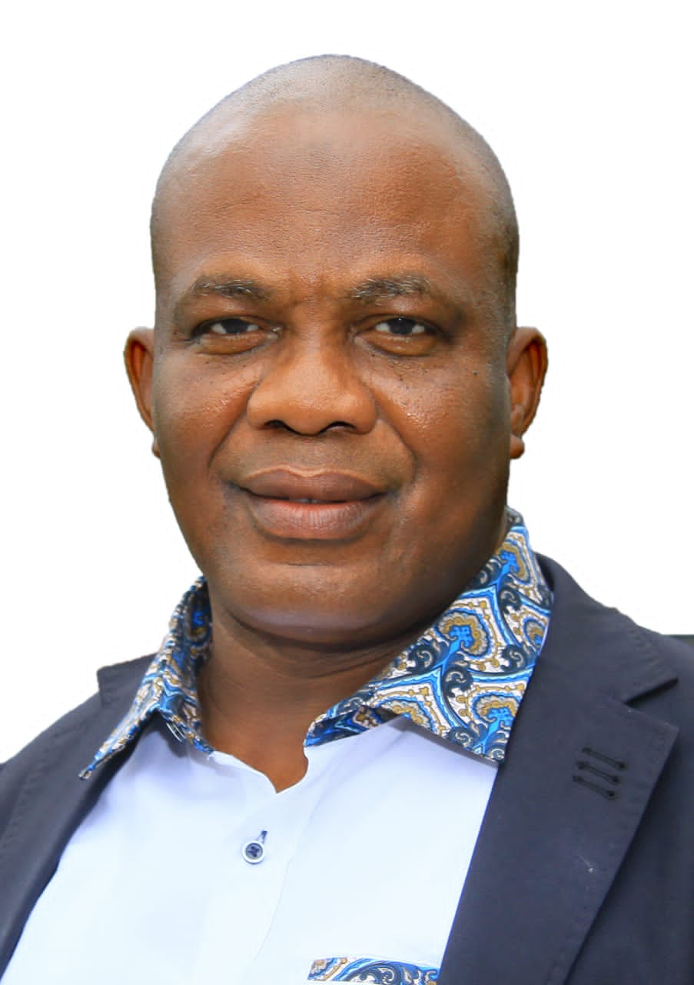

**MR. ADEWUYI ADEMOLA YEKEEN, IMMEDIATE PAST PPRESIDENT**